**Top React Native UI Libraries**

Are you looking to turbocharge your React Native app’s user interface without reinventing the wheel? Well, you’re in luck! In this article, we’ve scoured the React Native universe to bring you a comprehensive guide on the latest and greatest ***UI libraries that will not only make your app visually stunning but also boost its overall user experience.***

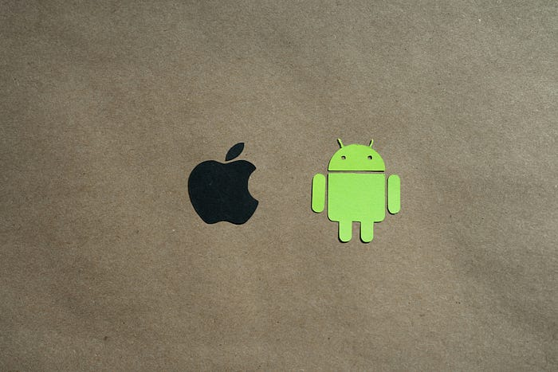

**1.**[**React Native Paper**](https://reactnativepaper.com/)**:**

First on our list is React Native Paper — *the go-to for giving your app that modern, polished look*. It’s like adding a layer of finesse to Material Design. Simple, effective, and developer-friendly, it’s a game-changer for UI enthusiasts.

**2. [Shoutem UI Toolkit](https://shoutem.github.io/" \t "_blank) :**

If you’re all about *simplicity and quick development*, the Shoutem UI Toolkit is your secret weapon. With pre-designed components that fit like puzzle pieces, you’ll be building a stunning interface without breaking a sweat.

**3.**[**UI Kitten**](https://akveo.github.io/react-native-ui-kitten/)**:**

Meet UI Kitten, where *style meets simplicity*. It’s like dressing your app in the latest fashion trends, offering not just functionality but a touch of sass. Customize your components and let your app strut its stuff.

**4.**[**Victory Native**](https://formidable.com/open-source/victory/)**:**

Ready to chart your path to success? Victory Native is *your buddy for data visualization*. Whether it’s graphs, charts, or complex visualizations, this library makes it a breeze. It’s like having a data Picasso for your React Native app.

**5. [NativeBase](https://nativebase.io/" \t "_blank) :**

Enter NativeBase —*the Swiss Army knife of UI components*. Buttons, cards, badges — you name it, NativeBase has got it. Plus, it plays well with others, ensuring your app stands out without compromising compatibility.

**6. [Maguns UI](https://magnus-ui.com/" \t "_blank) :**

Last but not least, let’s talk about Magnus UI — *the minimalist’s dream*. With a focus on simplicity and flexibility, it’s perfect for those who want a clean, no-nonsense UI. It’s like a breath of fresh air for your React Native project.

In conclusion, these carefully curated React Native UI libraries are your ticket to an enhanced app experience. Whether you’re aiming for Material Design finesse, streamlined development, stylish interfaces, or robust data visualization, these libraries have got you covered.

Remember, a **seamless user experience is the key to app success**. So, dive into these libraries, experiment, and watch your React Native app shine! Happy coding, and may your app reach new heights! 🚀

**1.**[**React Native Elements**](https://reactnativeelements.com/)

This project has 23.3K stars and 4.5K forks on [Github](https://github.com/react-native-elements/react-native-elements" \t "_blank),  You can find the [full walk-through here](https://reactnativeelements.com/blog/2018/12/13/react-native-web). They also provide a VS code [extension](https://marketplace.visualstudio.com/items?itemName=rne.snippets). Overall it is a vibrant open community to which anyone can contribute.

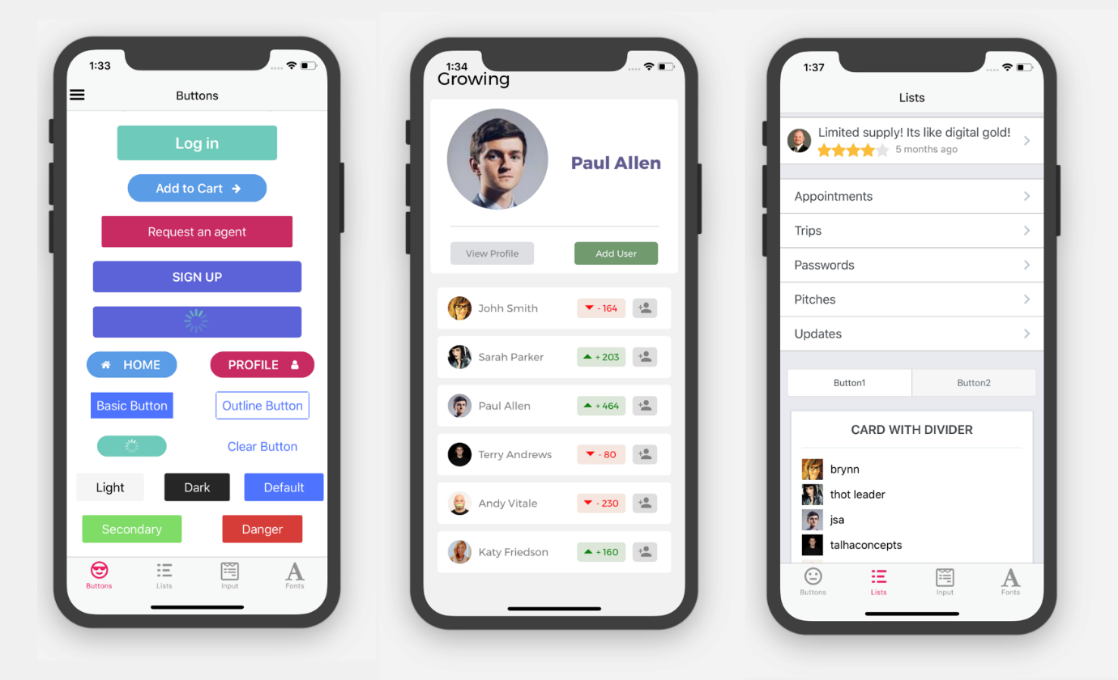

* A standout feature of React Native Elements is its range of components.
* From the standard UI elements like buttons and inputs to more specialized components like badges and avatars, React Native Elements has it all.
* The library also includes various components for navigation, such as headers and tabs, and features for handling user interactions, like checkboxes and switches.
* In addition to its comprehensive component library, React Native Elements also provides a powerful tool for creating dialogs and bottom sheets.
* The Dialog component can create custom dialog boxes, while the BottomSheet component provides an intuitive way to display additional content without taking up too much screen space.

**2.**[**React Native Paper**](https://reactnativepaper.com/)

This project has 10.3K stars and 1.9K forks on [Github](https://github.com/callstack/react-native-paper" \t "_blank), and is another popular UI component library for React Native app dets for developers to use in their apps.

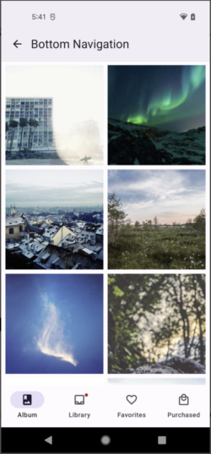 **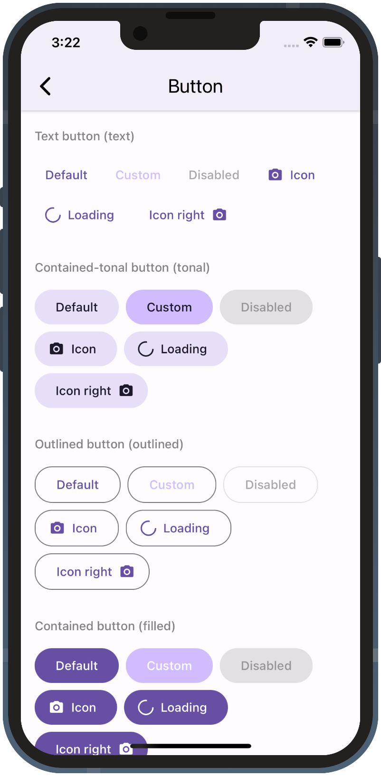**

**React Native Paper Demo**

* One of the key differentiators of React Native Paper is its focus on providing a consistent look and feel across all components.
* The library uses Material Design styles and themes, ensuring that apps developed using React Native Paper have a cohesive and professional appearance.
* In addition to its focus on consistency, React Native Paper also provides several powerful components for user interactions and navigation.
* The library includes components for buttons, inputs, and tabs, as well as features for handling user interactions with multimedia.
* Another standout feature of React Native Paper is its customizable appearance. Developers can easily adjust the styles of components to match the specific needs of their app, while still maintaining a consistent look and feel.
* This customization also extends to themes, which can be adjusted to change the overall look and feel of the app.

**3.**[**Native Base**](https://nativebase.io/)

This project has 19k stars and 2.3k forks on [Github](https://github.com/GeekyAnts/nativebase" \t "_blank). It is an accessible, utility-first component library that helps build consistent UI across android, iOS and web.

* One of the standout features of Native Base is its extensive collection of pre-built components, including buttons, inputs, headers, cards, and more.
* This library covers most of the common UI elements developers need in their apps, making it a one-stop shop for many developers.
* Another important feature of Native Base is its utility-first approach.
* The library provides several useful tools and functionalities that developers can use to make their app development process more efficient and streamlined. For example, the library includes tools for handling platform-specific styling and component behavior, making it easier for developers to create cross-platform apps.
* It is highly customizable, with developers able to easily change the styles and appearance of components to suit the specific needs of their app. This customization is achieved through themes, which can be adjusted to change the overall look and feel of the app.

**4. [Shoutem UI](https://shoutem.github.io/" \t "_blank)**

With 4.8k stars and 500+ forks on [Github](https://github.com/shoutem/ui" \t "_blank), these components are built to be both composable and customizable. Each component has a predefined style compatible with the rest of the Shoutem UI, making it possible to build complex components.

* The library provides a powerful theme engine, allowing developers to change their app’s look and feel easy. This customization can be done globally, or on a per-component basis.
* Shoutem UI also provides a comprehensive set of UI components for navigation, user interactions, and data display.
* This includes components for buttons, inputs, cards, and more. The library also includes components for handling user interactions, such as checkboxes, switches, and sliders.
* Another unique aspect of Shoutem UI is its support for extensions. Developers can build their own custom components or add third-party components to the library, making it easy to extend and customize the library to meet the specific needs of their app.

**5.**[**React Native Material UI**](https://www.react-native-material.com/)

Is another set of modular and customizable Material Design UI components for React Native with 150+ stars on [Github](https://github.com/yamankatby/react-native-material" \t "_blank). It provides a comprehensive set of UI components, from basic elements like buttons and inputs to more complex components like progress bars and cards.

* One of the key features of React Native Material UI is its modular design, which allows developers to easily pick and choose which components they need for their specific project.
* This results in a faster development process, as developers can easily add or remove components as needed.
* In addition to its modular design, React Native Material UI offers customization options for its components in addition to its modular design. This means developers can easily adjust the look and feel of components to match their specific needs while still maintaining a consistent overall appearance.
* Another standout feature of React Native Material UI is its focus on accessibility. The library includes accessibility features like keyboard navigation and screen reader compatibility, making it easier for developers to create accessible, user-friendly apps.